STEP 1:Spencers Wood FC Registration; (Specific Link to form; all details & consent)
- Select the link to the registration forms: https://www.gotfootball.co.uk/asp/application/reg/?ProgramID=4191&Type=PLAYER
a. If you are an existing player enter Username and password under individual users – existing account. If you do not know your username or password please use player password lookup.
b. If you have more than one player in the club please create a family account. Select Create Family account.
GotFootball’s Family Accounts are placeholder accounts that allow you to edit personal data for individual players. The Account can be used to register and pay fees to your club, and is needed for the system to know that individual players are members of the same family and make available sibling discounts. (See appendix 1 for more information on family account).
c. If you are a coach or committee member entitled to discount please use this link instead https://www.gotfootball.co.uk/asp/application/reg/?ProgramID=4192&Type=PLAYER
d. If you are a New player please complete the Individual Users – New Account. All new players require a proof of age document - birth certificate, passport or driving licence (a photo of it taken from your phone and uploaded is acceptable). (See Appendix 2 for more information on uploading proof of age documents)
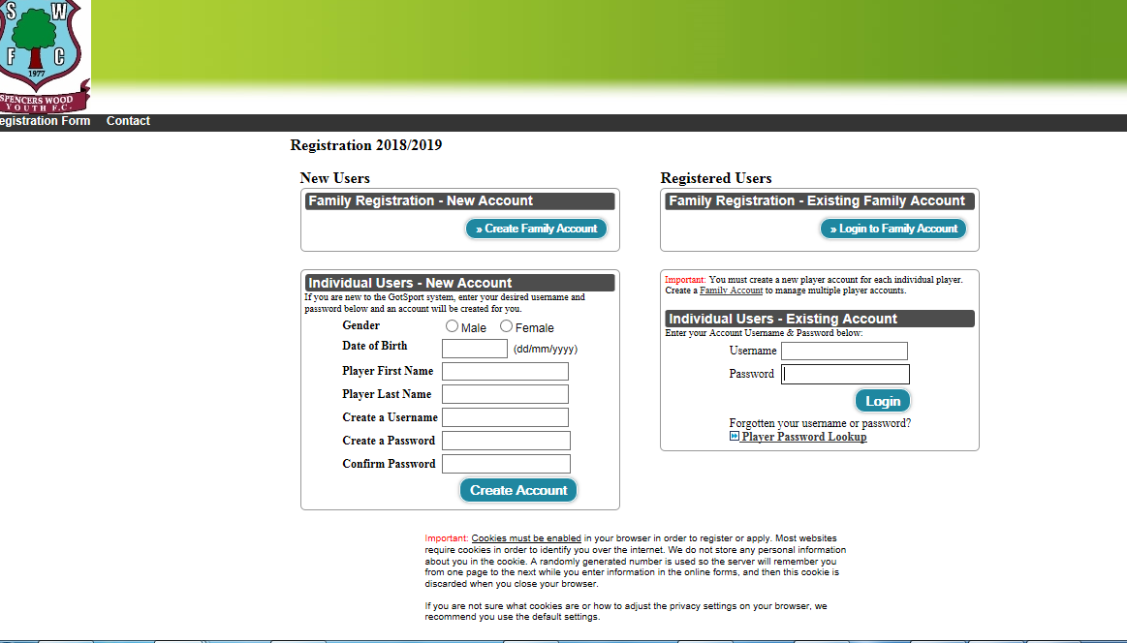

2. Input and/or check and update the player’s contact information. Please ensure the correct contact telephone number and email address is entered.
3. If you have been provided with a voucher code you can input the code underneath the Team selection.
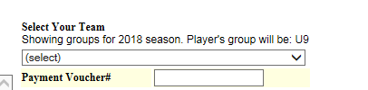

4. If you are training ONLY please select Spencers Wood Youth FC Training Only from the team drop down list. Further down the page you will see a text box that allows you to enter which team you will be training with.
5. You will see codes of conduct, terms and conditions and permissions. To confirm you have read the text you will need to select the tick box, with permissions you need to select from the drop down menu and enter GP name and surgery details in the text box.
6. Once all boxes have been completed select continue.
7. Enter medical information. Please include any medical conditions that the coach/club need to be aware of. Select Continue.
8. Payment: Select your payment option. Select Continue.
9. Check the information is correct. Enter your name and select the tick box to confirm you agree to the terms.
10. You will be taken to a page where you need to complete your payment details. You will receive an email to confirm payment.

STEP 2 : East Berkshire FA Registration (photo/consent & if new; proof of age document) - https://www.gotfootball.co.uk/asp/players/login.asp?msg=
11. You must now upload a photo by clicking Upload Photo Now Button. Choose a file and upload the image. Photographs need to have been taken within last 3 months in a passport style photograph of head and shoulders against a white back ground (from your phone is acceptable). Any photographs not fitting this description will not be accepted.
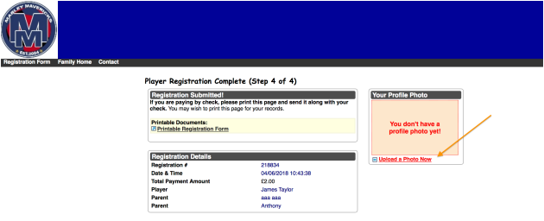

12. To upload your photo; you will be taken to your profile page. OR you can log in via this link using your individual player username and password. https://www.gotfootball.co.uk/asp/players/login.asp?msg=
Once you have uploaded a photo you can click on the welcome tab to complete the East Berks FA Required League forms to allow you to play in the East Berks league. YOU CANNOT COMPLETE CONSENT FORMS FROM FAMILY ACCOUNTS, YOU MUST LOG INTO INDIVIDUAL PLAYER ACCOUNTS. You will see a link for Form Available .
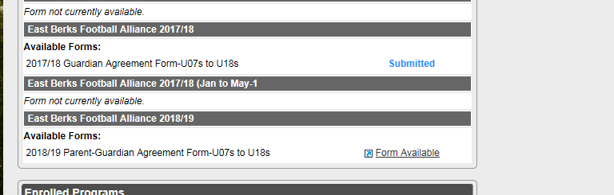

13. Choose the child’s club. IMPORTANT - make sure you select the correct club, as many clubs share similar names. Type in your full name. Read the consent form and digitally sign the form, if you agree, by ticking the box and clicking continue.
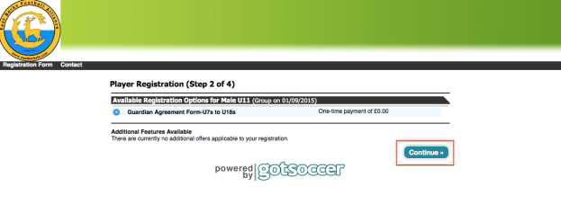

14. Click the Continue button.
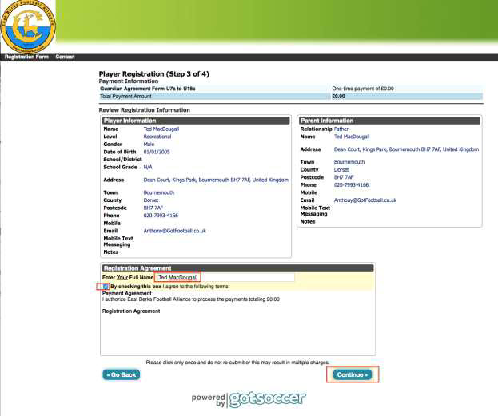

15. Review your information. Enter your name. Tick the agreement box and then click the Continue button. (There is no payment charge)
16. A confirmation of your submission will show.
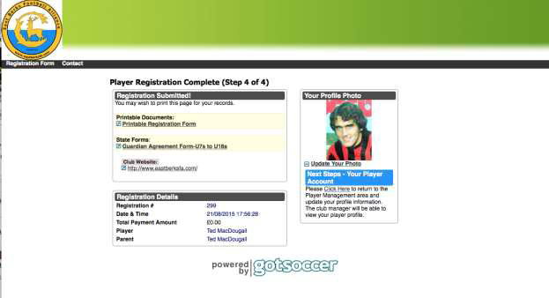

STEP 3 : FA Requirement - (Approve/Reject link to player)

17. Once registered with Spencers Wood FC and consent is given to play in the East Berks FA League your child is required to be registered on the FA Wholegame database. You will receive an email from the FA and are required to set up an account if you don’t have one OR log in with your FA username and password and select APPROVE. Instructions including a YouTube video can be found here: https://grassrootstechnology.thefa.com/support/solutions/articles/48001119567-new-email-capture-tool-for-youth-adult-players
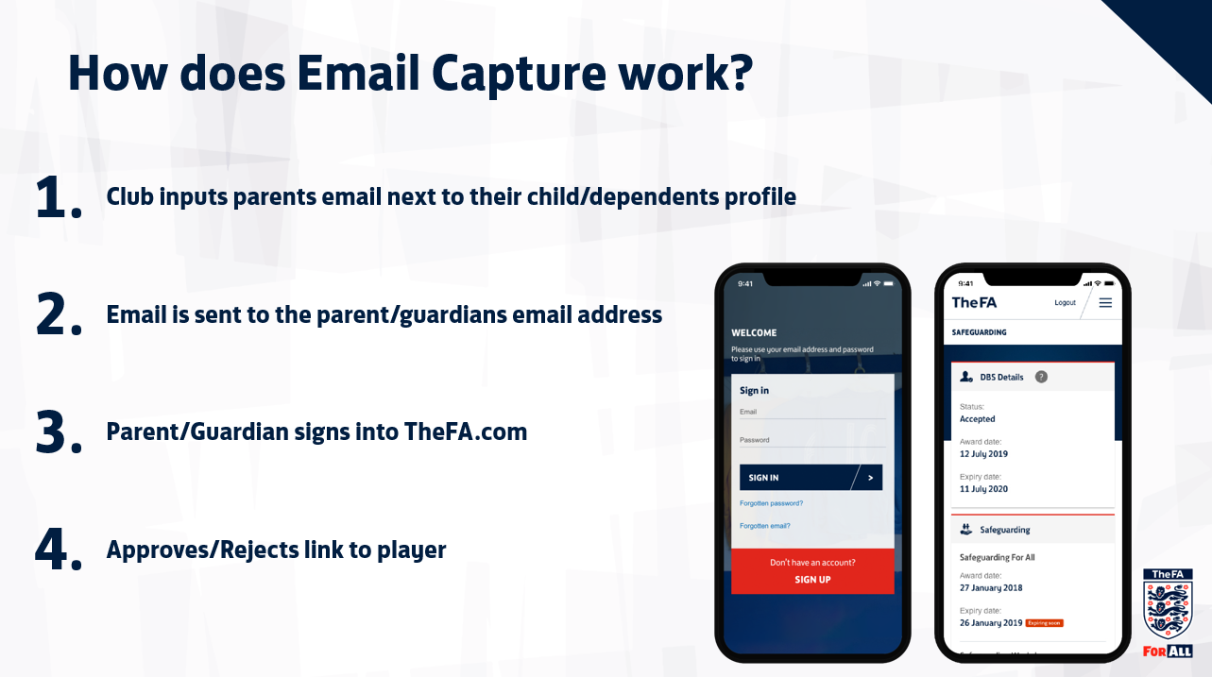

I. Select Create Family Account
APPENDIX 1

CREATING A FAMILY ACCOUNT
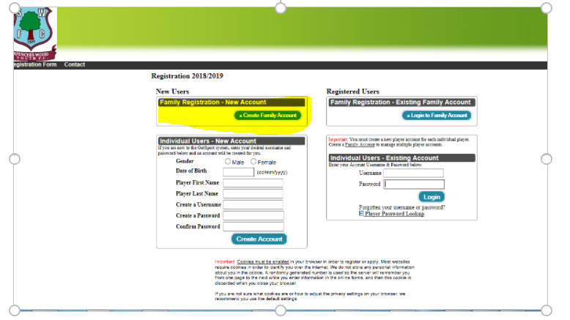
II. Enter name, username and password and register.
III. If your child is new to GotFootball you can create a brand-new Player Account or you can add an existing Player Account by adding their username and password
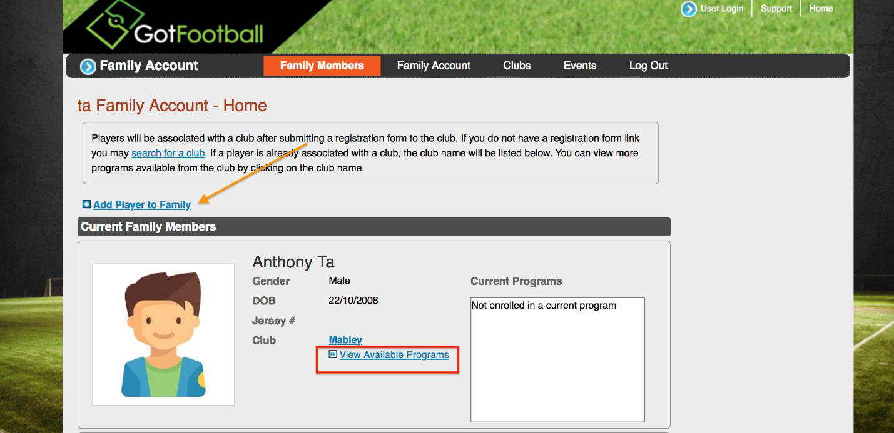
iv Once you have added a player you can search for the player’s club if they are not already assigned to a club or add another player.

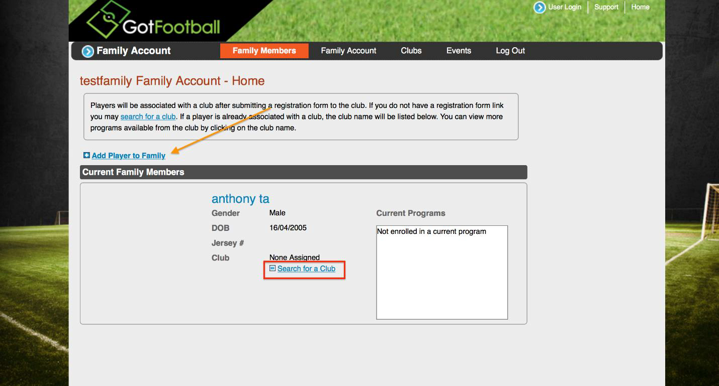
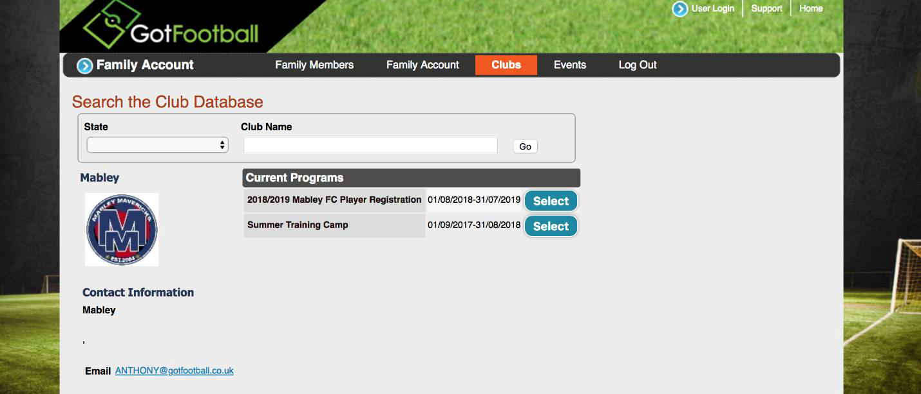
v If you child is already assigned to a club you can click to view their available programmes.
vi Select the programme of choice and go back to step 2.
To complete the sibling form, after completing first child you need to click back in “family home” then go to “register now” on second child.

APPENDIX 2

UPLOADING PROOF OF AGE DOCUMENT – NEW PLAYERS ONLY

If you are a New player please complete the Individual Users – New Account. All new players require a proof of age document - birth certificate, passport or driving licence (a photo of it taken from your phone and uploaded is acceptable).
http://www.gotfootball.co.uk/p.aspx?p=Login
- Log into “player account” using your username and password.
- Select “My Profile” tab.
- Select “Club Documents “ then select Upload Document for Spencers Wood Youth FC (Berkshire).
- Select “Browse” select your proof of age document and then select “Upload”.

